Ad pause

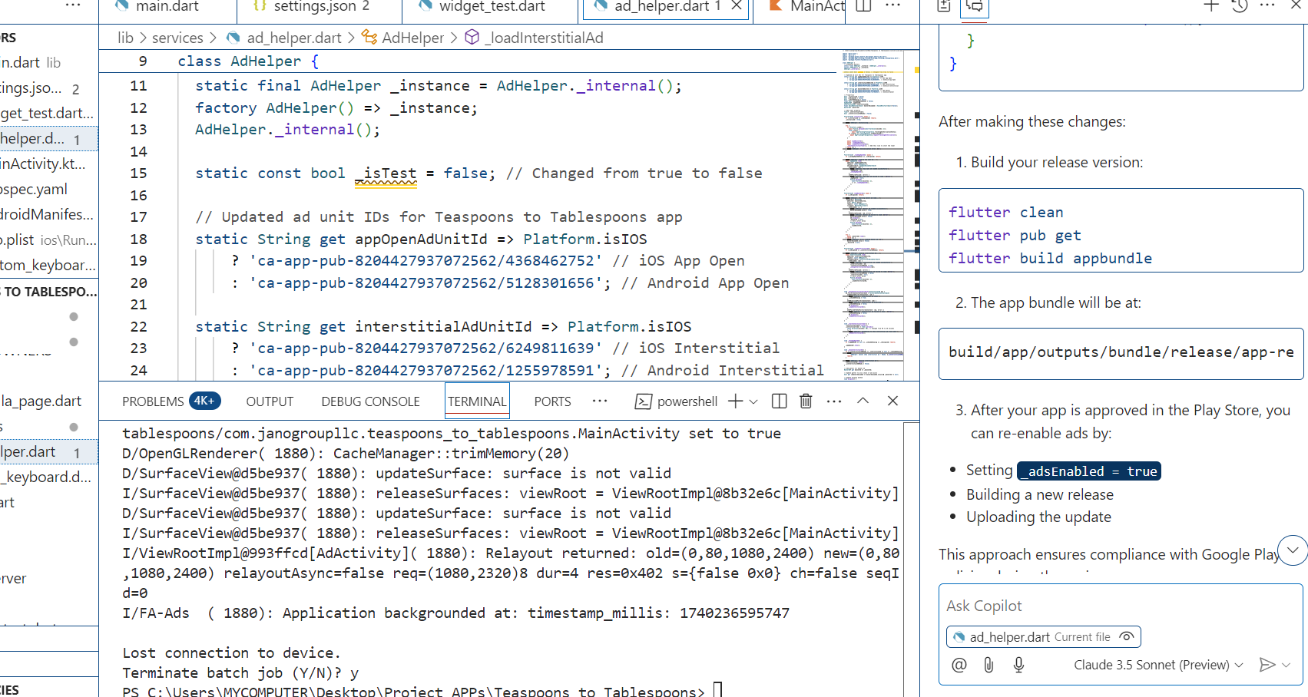

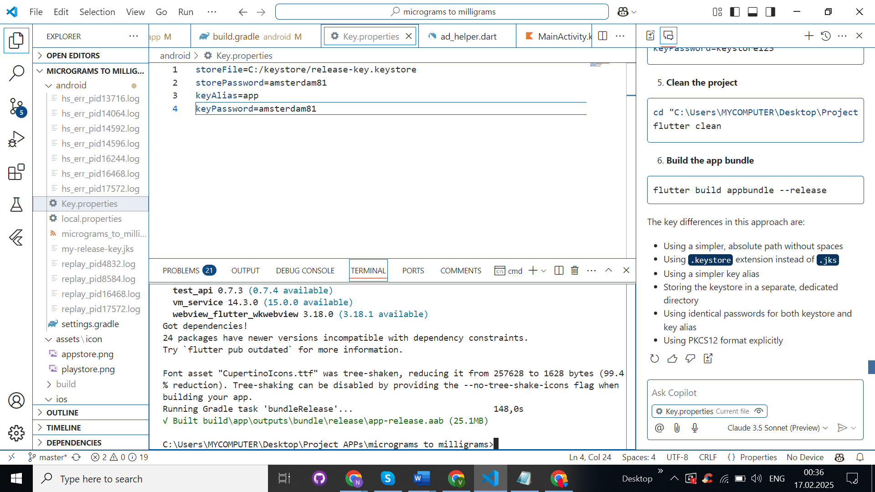

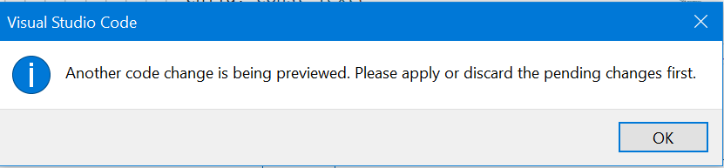

Bottom nav bar

Dots

Zero

minus

Separate page where formula will be

Moving input fields

App name correction

https://www.appicon.co/ app icon

feature graphic link: <https://hotpot.ai/templates/google-play-feature-graphic>

app bundle file: C:\Users\MYCOMPUTER\Desktop\Project APPs\celcius_to_fahrenheit_converter\android\build\app\outputs\bundle\release

App id

Android:

IOS:

App Open IDs

Android:

IOS:

Interstitial IDs

Android:

IOS:

Banner IDs:

Android:

IOS:

Micrograms to Milligrams

App id

Android: ca-app-pub-8204427937072562~4856867166

IOS: ca-app-pub-8204427937072562~7448963801

App Open IDs

Android: ca-app-pub-8204427937072562/3801933659

IOS: ca-app-pub-8204427937072562/3098655252

Interstitial IDs

Android: ca-app-pub-8204427937072562/9726050469

IOS: ca-app-pub-8204427937072562/4411736928

Banner IDs:

Android: ca-app-pub-8204427937072562/9325723076

IOS: ca-app-pub-8204427937072562/4822800464

Gallons to Liters

**App id**

Android: ca-app-pub-8204427937072562~2114421233

IOS: ca-app-pub-8204427937072562~3976838257

**App Open IDs**

Android: ca-app-pub-8204427937072562/7616700362

IOS: ca-app-pub-8204427937072562/5746544484

**Interstitial IDs**

Android: ca-app-pub-8204427937072562/5652882000

IOS: ca-app-pub-8204427937072562/2525748105

**Banner IDs:**

Android: ca-app-pub-8204427937072562/5726626513

IOS: ca-app-pub-8204427937072562/7642343411